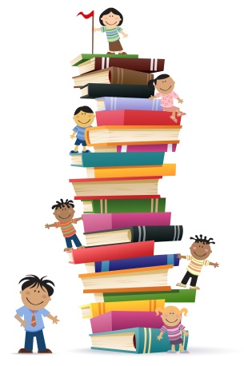
30 Book Challenge

What is the 30 Book Challenge?
Students will be reading daily at school and at home to reach a goal of 30 books at their individual reading level by the end of the school year.

What kinds of books will the students be reading?
Students are given a list of book categories (also called genres) such as mystery or biography. It lets them know how many books they need to read from each reading genre.

How does the teacher know my child has read a book?
Students will be asked to complete a simple book report form to show they have read the book and it was a comfortable reading level, not too easy and not too hard.

How will I know if my child is making good progress with the Challenge?
I will communicate your child’s progress a few times each marking period. If your child starts getting too far behind, I will let you know.

Where will students get the books to read?
Students are able to check out 2 books each week from the school library. I also have a nice selection of books in our classroom library that have been organized by the different categories.

Why is the teacher having my child do a 30 Book Challenge?
There are many benefits to participating in the Challenge. By fourth grade students need to work on endurance, being able to read for longer periods of time and still be able to comprehend what they are reading. Another benefit is that students get to try out books that they might not have experienced before and often find something new they love to read.

How can I help my child with the Reading Challenge?
Students should always have a book they are reading for the challenge or a book report to complete if they have just finished a book. This can be part of their homework time after school.

***Look below for the book list your child will be using for the Challenge.
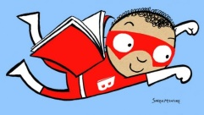
30 Book Challenge

5 Realistic Fiction
A story using made-up characters that could happen in real life.

2 Historical Fiction
A fictional story that takes place in a particular time period in the past. Often the setting is real, but the characters are made up from the author’s imagination.

2 Fantasy
A story including elements that are impossible such as talking animals or magical powers. Make-believe is what this genre is all about.

2 Science Fiction
A type of fantasy that uses science and technology (robots, time machines, etc.)

2 Mystery
A suspenseful story about a puzzling event that is not solved until the end of the story.

2 Poetry
Poetry is verse written to create a response of thought and feeling from the reader. It often uses rhythm and rhyme to help convey its meaning.

3 Biography
The story of a real person’s life written by another person.

5 Informational
Texts that provide facts about a variety of topics (sports, animals, science, history, careers, travel, geography, space, weather, etc.)

7 Your Choice
These can be from any genre.

