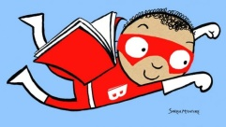
30 Book Challenge

5 Realistic Fiction
A story using made-up characters that could happen in real life.

2 Historical Fiction
A fictional story that takes place in a particular time period in the past. Often the setting is real, but the characters are made up from the author’s imagination.

2 Fantasy
A story including elements that are impossible such as talking animals or magical powers. Make-believe is what this genre is all about.

2 Science Fiction
A type of fantasy that uses science and technology (robots, time machines, etc.)

2 Mystery
A suspenseful story about a puzzling event that is not solved until the end of the story.

2 Poetry
Poetry is verse written to create a response of thought and feeling from the reader. It often uses rhythm and rhyme to help convey its meaning.

3 Biography
The story of a real person’s life written by another person.

5 Informational
Texts that provide facts about a variety of topics (sports, animals, science, history, careers, travel, geography, space, weather, etc.)

7 Your Choice
These can be from any genre.

